HOW TO HACK FACEBOOK ACCOUNT AND GMAIL ACCOUNT USING BACKTRACK 5


HELLO

I AM SOLITARY MAN TODAY I AM TEACH YOU HOW TO HACK FACEBOOK ACCOUNT AND GMAIL ACCOUNT USING BACKTRACK 5

1)DOWNLOAD NOW BACK TRACK R5NOW START

IN MY PREVIOUS TUTORIAL I HAVE EXPLAINED “ HOW TO HACK FACEBOOK ACCOUNT USING PHISHING ” ,THISNOWTUTORIALIN I AM GOING TO SHOW YOU HOW TO HACK FACEBOOK ACCOUNT USING BACKTRACK 5. SO JUST FOLLOW THE SIMPLE STEPS.

2)

OPEN YOUR BACKTRACK 5’S TERMINAL AND TYPECD /PENTEST/EXPLOITS/SET

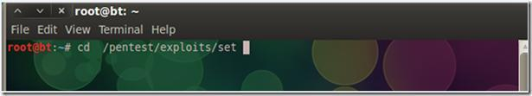

Now Open social Engineering Tool kit (SET) ./set
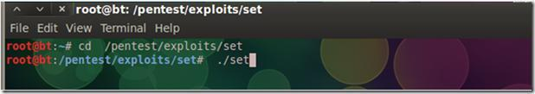

Just hit ENTER and SET will Open , Now just select 1st option (1 Social-Engineering Attacks) and hit enter after that 2nd number (just type 2 as shown in snapshot)
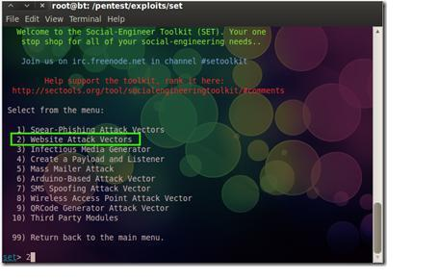

Now Just select 4th Option “Tabnabbing Attack Method” and
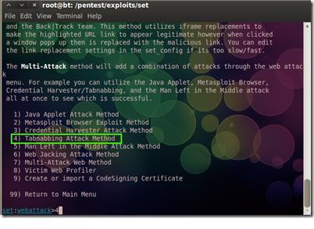

Then select 2nd option “Site Cloner” and Hit ENTER
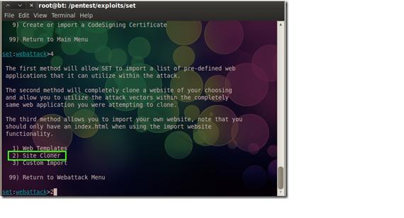

Now here you need to add the URL of Facebook (if you want to hack gmail then just add the gmail’s URL)
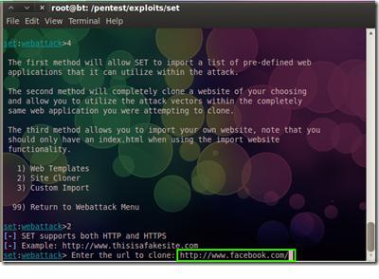

Now just hit the enter.
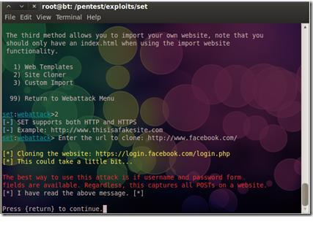

Open new terminal and just type ifconfig and hit ENTER
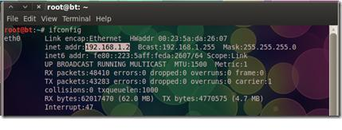

Now just copy this IP address and open it in Browser.
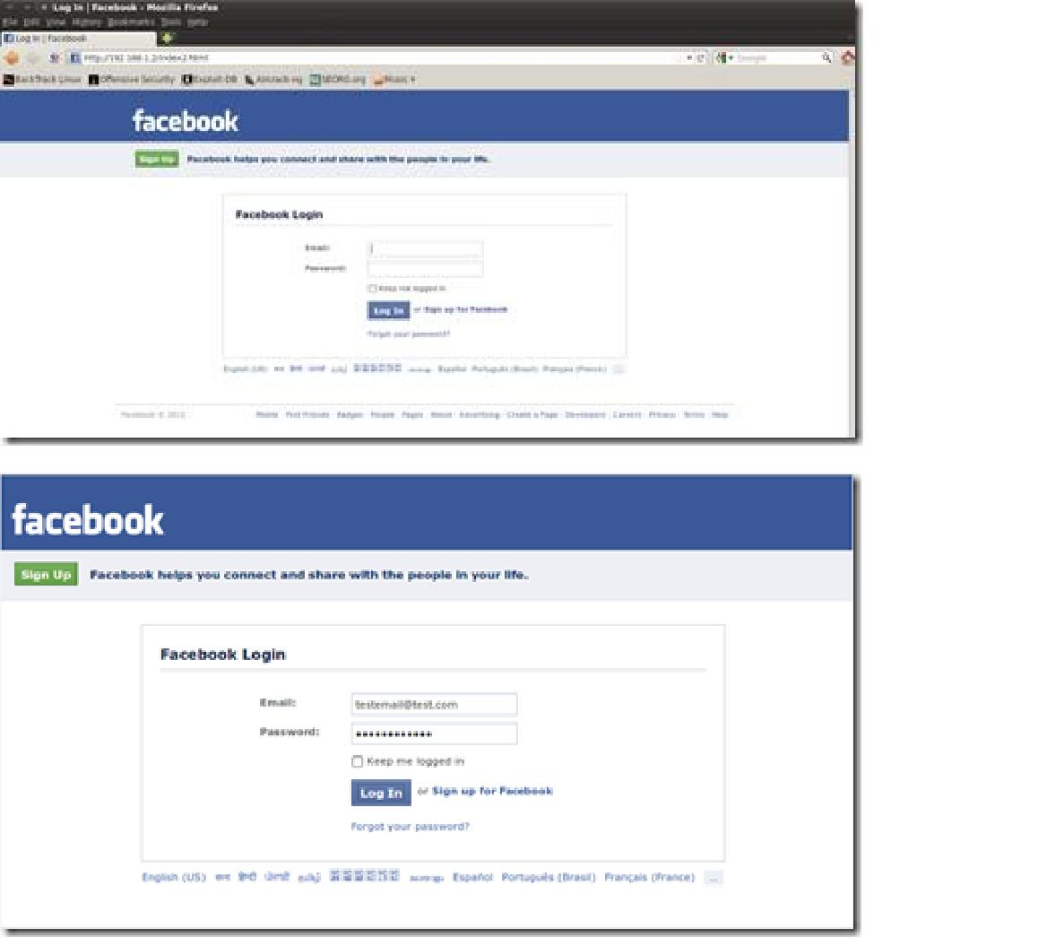

Now here I am just typing test email and password to see whether it works or not.

Now just hit enter and switch back to our terminal and we found the Email and password !
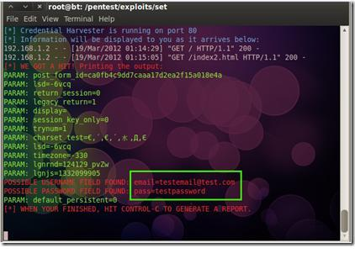

This tutorial is just educational purpose only. any porblm plz comment :)

